|  |  |  |  |  |
| --- | --- | --- | --- | --- |
| 0 | 64 | 128 | … |  |
| 1 | 65 | 129 | … |  |
| 2 | 66 | 67 | … |  |
| … | … | … | … | … |
| 63 | 127 | 191 | … | 2047 |

Main Memory

Cache

|  |
| --- |
| 0 |
| 1 |
| … |
| … |
| 2046 |
| 2047 |

|  |
| --- |
| 0 |
| 1 |
| … |
| … |
| 62 |
| 63 |

Page

|  |  |  |  |
| --- | --- | --- | --- |
| Word0 | Word2 | Word3 | Word4 |

MAR

|  |  |  |
| --- | --- | --- |
| Tag 5 | Line (Index) 6 | Offset 2 |

64

lines

Main Memory (2048 pages)

Cache

|  |  |  |  |  |
| --- | --- | --- | --- | --- |
| 0 | 64 | 128 | … | 1983 |
| 1 | 65 | 129 | … | 1984 |
| 2 | 66 | 67 | … | 1985 |
| … | … | … | … | … |
| 63 | 127 | 191 | … | 2047 |

|  |
| --- |
| 0 |
| 1 |
| 2 |
| … |
| 62 |
| 63 |

32

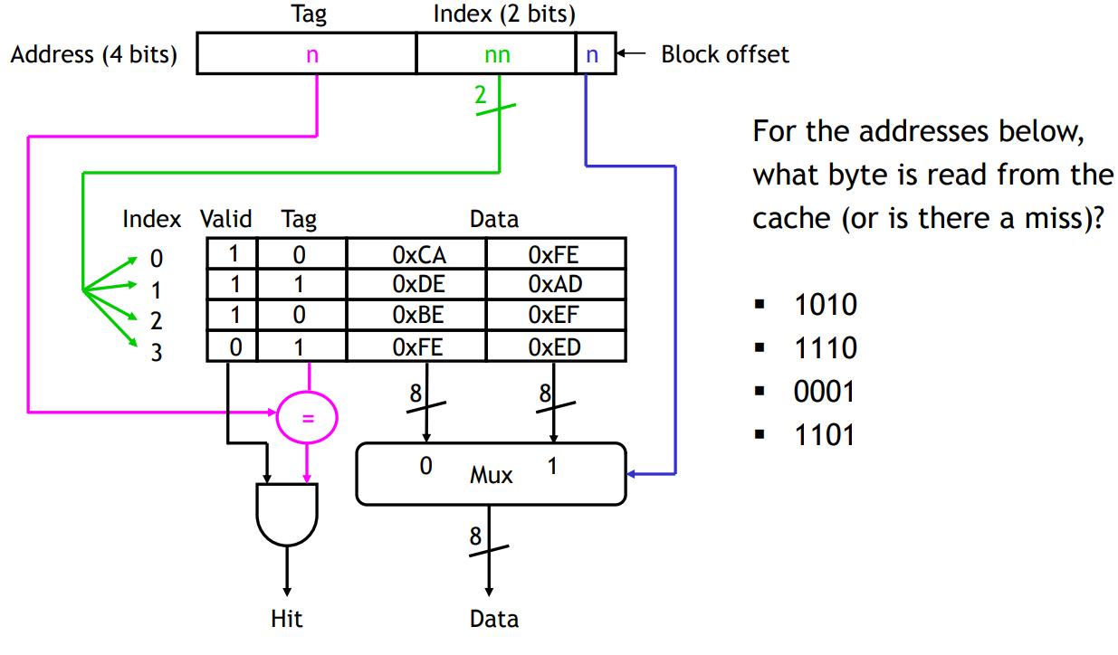

|  |  |  |  |
| --- | --- | --- | --- |
| Address  13 bits | Tag  11001 | Line (Index)  000001 | Offset  10 |

|  |  |  |  |  |  |  |
| --- | --- | --- | --- | --- | --- | --- |
| Line | Valid | Tag | Data | | | |
| 0 | 1 | 00101 | A0 | A1 | A2 | A3 |
| 1 | 1 | 11001 | B0 | B1 | B2 | B3 |
| … | … | … | … | … | … | … |
| 62 | 0 | 00000 | E0 | E1 | E2 | E3 |
| 63 | 1 | 11011 | F0 | F1 | F2 | F3 |

MUX

Hit

B2



Main Memory

Cache

|  |
| --- |
| 0 |
| 1 |
| … |
| … |
| 2046 |
| 2047 |

|  |
| --- |
| 0 |
| 1 |
| … |
| … |
| 62 |
| 63 |

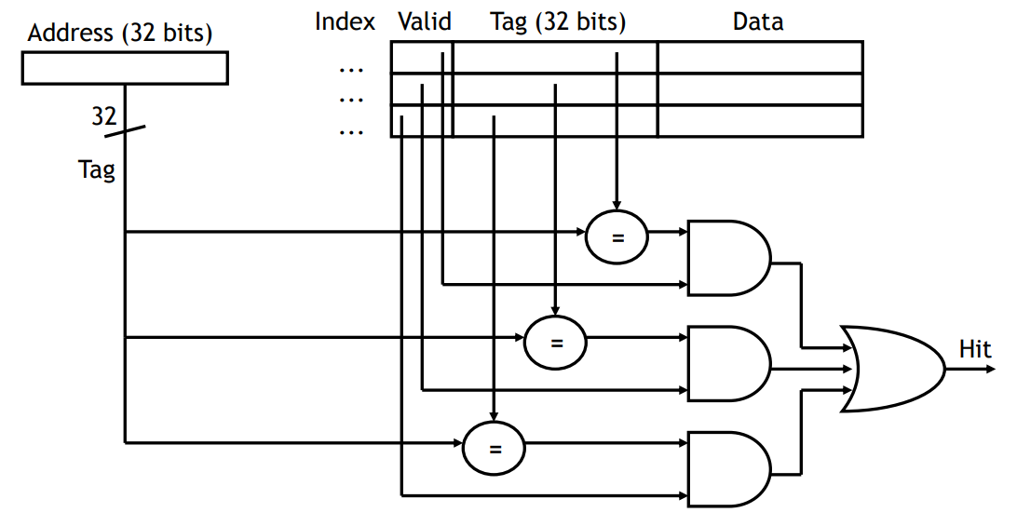

Cache

32

lines

Main Memory (2048 pages)

|  |  |  |  |  |
| --- | --- | --- | --- | --- |
| 0 | 32 | 64 | … | 2016 |
| 1 | 33 | 65 | … | 2017 |
| 2 | 44 | 66 | … | 2018 |
| … | … | … | … | … |
| 31 | 63 | 95 | … | 2047 |

|  |  |
| --- | --- |
| Set | Line |
| 0 | 0 |
| 1 |
| 1 | 2 |
| 3 |
| … |  |
|  |
| 31 | 62 |
| 63 |

64

|  |  |
| --- | --- |
| MAR | |
| Tag 11 | Offset 2 |

|  |  |  |  |
| --- | --- | --- | --- |
|  | MAR | | |
| Tag 6 | | Line 5 | Offset 2 |

|  |
| --- |
| Address (13 bit) |

|  |  |  |  |  |  |  |
| --- | --- | --- | --- | --- | --- | --- |
| Line | Valid | Tag | Data | | | |
| … | 1 | … | … | … | … | … |
| … | 1 | … | … | … | … | … |
| … | … | … | … | … | … | … |

Tag

11bit

Hit

11bit

